PowerShell Function to report free disk space on Servers (Get-FreeDiskSpace)

Get-FreeDiskSpace is an Advanced PowerShell function for reporting free disk spaces on servers. It may report on a single server if the -Servername parameter is specified; It may report on servers from a text file if the -Serverfile parameter is specified. Report for a single server is displayed on the console; report for servers from a text file is stored on a CSV file located in \CSVReports folder.

Get-FreeDiskSpace function comes with error logging. Any server that is offline or with wrong name will be logged in the \logs folder. All other errors are displayed on the console.

## Installation and examples

Follow the steps below to install and use the Get-FreeDiskSpace PowerShell function:

#1. Download and unzip Get-FreeDiskSpace.zip.

#2. Copy Get-FreeDiskSpace folder to the following locations: \Documents\WindowsPowerShell\Modules and/or \Program Files\WindowsPowerShell\Modules

#3. Run the command: **Import-Module** **Get-FreeDiskSpace**

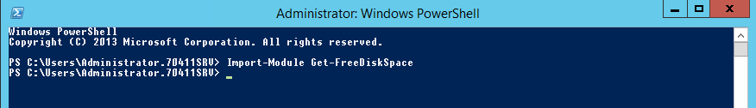

#4. To get help and information about the Get-FreeDiskSpace function, run the command:

**Get-Help Get-FreeDiskSpace**

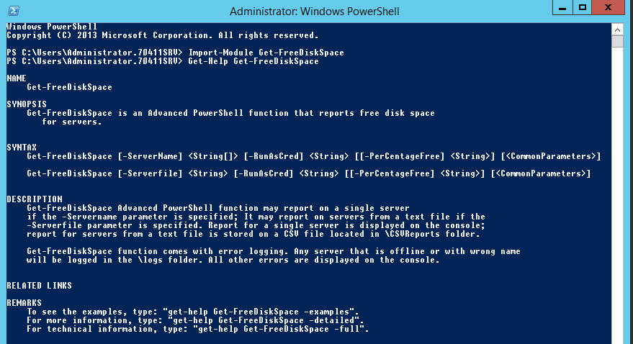

To get detailed help, run **Get-Help Get-FreeDiskSpace -Detailed.** To get Full help, run  
**Get-Help Get-FreeDiskSpace -Full**

#5. To run disk report for a single server with the default PerCentageFree parameter (10%), enter the following commands:

**Get-FreeDiskSpace -ServerName** **70411SRV1 -RunAsCred** **70411Lab\administrator**

You will be prompted to authenticate the account you entered above:

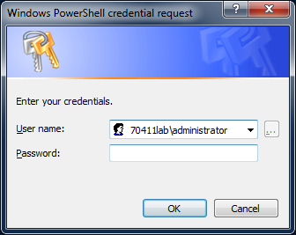

NOTE: This account MUST have administrator privileges on all servers you wish to run disk report on

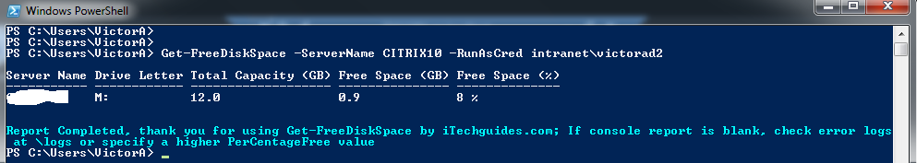

#6. To run disk report for a single server with a higher PerCentageFree (reports free space for all drives less than or equal to 30% free space) parameter, enter the following commands:

**Get-FreeDiskSpace -ServerName 70411SRV1-RunAsCred 70411Lab\administrator -PerCentageFree 30**

Confirm your password: Notice that more drives are now returned for the same server:

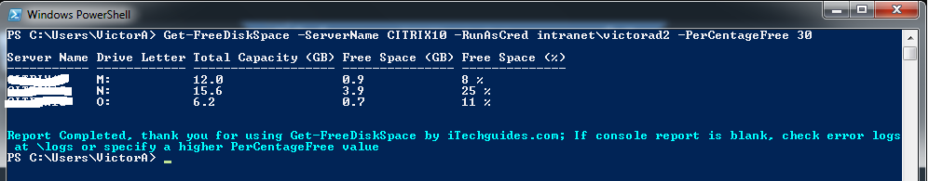

#7. To run a report from a text file as input and return free space on all drives, enter the commands below:

**Get-FreeDiskSpace -Serverfile 'E:\Imput\Servers.txt' -RunAsCred 70411lab\administrator -PerCentageFree 100**

Confirm your account: Report will take a while and return as shown below:

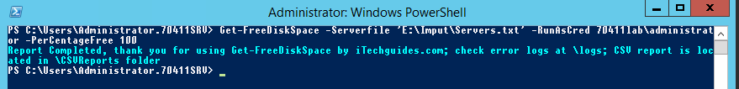

As indicated in the console, a CSV report has been created in the location:

C:\Program Files\WindowsPowerShell\Modules\Get-FreeDiskSpace\CSVReports.

Report has same headers as the console report for a single server:

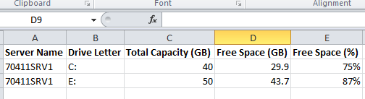

Error Handling:

#e1. If you enter a folder path instead of a text file path, the following errors will be returned:

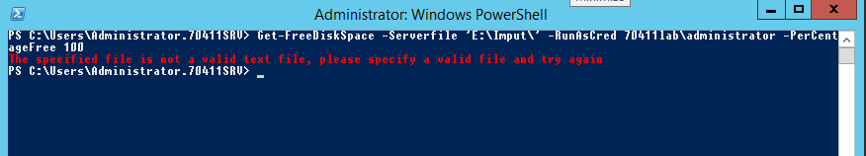

#e2. When you run report from a text file, all servers that could not be reached are logged in the \logs folder. Mine was logged in the following location:

C:\Program Files\WindowsPowerShell\Modules\Get-FreeDiskSpace\logs.

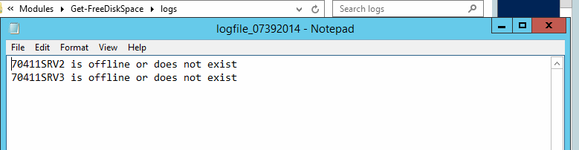

Thank you for using Get-FreeDiskSpace by iTechguides.com.

Download more PowerShell functions and iTechguides.com/blog